***Done by:***

***Ahmed* Wael**

***\*\*\*\*\*\*\*\****

***Hossam* Hassan,**

***\*\*\*\*\*\*\****

***Youssef* Alaa**.

**Cat and Mouse Game**

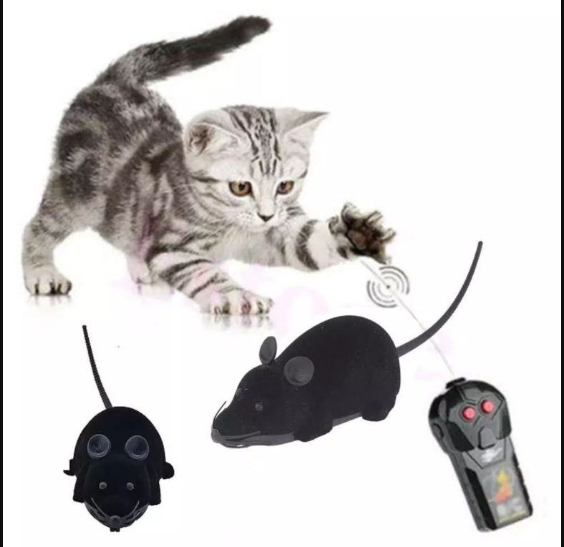

This is a game of mouse and cat where the mouse should survive in the game by.

The game is designed by Pygame library in python.

The mouse can be controlled by the user using keyboard arrows or controlled by the computer by going in random position

**Scenarios**

The game contains 4 scenarios(1 win scenario, 3 lose scenarios)

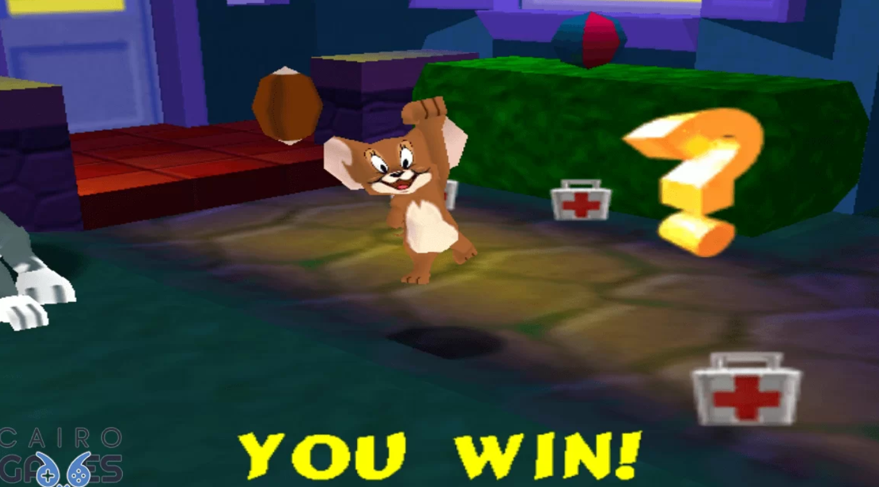**Win Scenario** : When The mouse reaches the green bridge

***Lose Scenarios***

1. When it hits the red cat
2. When it drowns in blue water
3. When it starves due to moving 20 steps

# Game Flow :

1. The game starts with mouse and cat in position
2. If it controlled by user the mouse will move by keyboard arrows   
   if it controlled by computer it will go in random position .
3. And it will perform one of the above scenarios .
4. If win scenario it will type ‘you won’.
5. If lose scenario it will type ‘game over’.